Farxod Qarshiyev 220090

There were Eslint problems then i fixed them
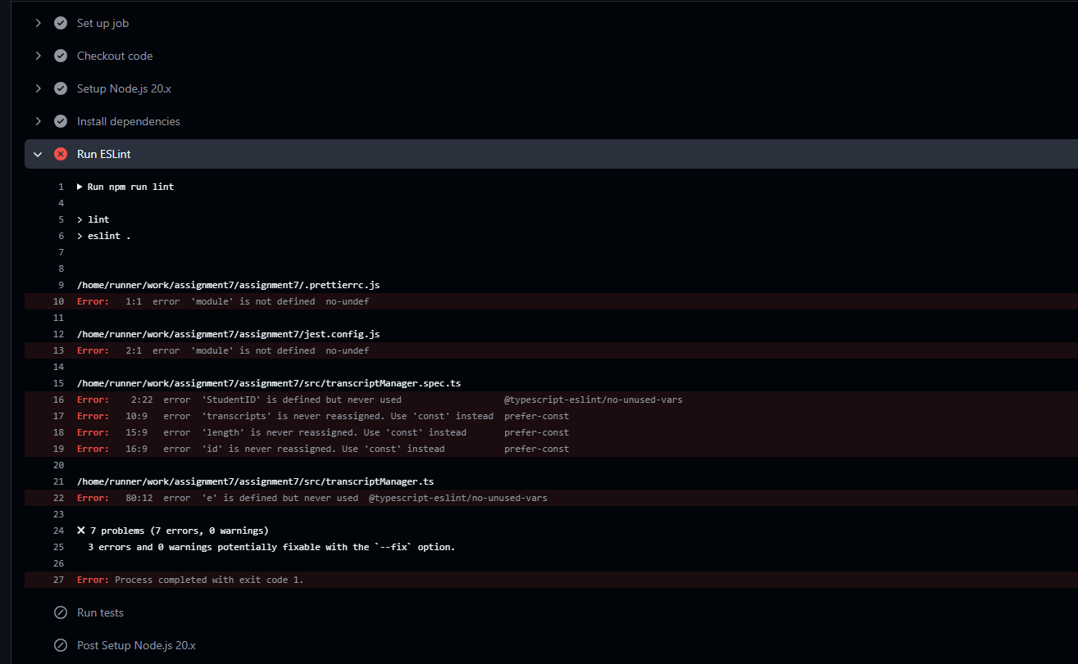
But there were still problems
